Networks Assignment 4

Group 21

Application 3

PART A Observations

PART-A: Started only one flow and analyzed the throughput over sufficiently long duration. Mentioned how we selected the duration. Plotted evolution of congestion window w.r.t. time. Performed this experiment with all the flows attached to all the three sending agents.

Also included goodput and throughput graphs and values.

We have created a Dumbbell topology with two routers R1 and R2 connected by a (10 Mbps, 50 ms) wired link. Each of the routers is connected to 3 hosts i.e., H1 to H3 (i.e. senders) are connected to R1 and H4 to H6 (i.e. receivers) are connected to R2. The hosts are attached with (100 Mbps, 20ms) links. Both the routers use drop-tail queues with queue size set according to bandwidth-delay product. Senders (i.e. H1, H2 and H3) are attached with TCP Hybla, TCP Westwood+, and TCP YeAH-TCP agents, respectively.

We used NS3 3.28 flow monitor module to collect and store performance data from the simulation.

Attached below are the output graphs for the three congestion protocols that we have used, namely, TCP Hybla, TCP Westwood+ and TCP Yeah.

The observations were taken until there was no appreciable difference noted in the pattern of the output. Once the outputs had monotonised or fallen into a repetitive pattern, we stopped recording observations.

**Congestion Loss for Hybla:**

Tcp Hybla Flow 3 (100.101.2.1 -> 100.101.6.1)

Total Packet Lost: 460

Packet Lost due to buffer overflow: 0

Packet Lost due to Congestion: 460

Maximum throughput(in kbps): 1018.22

Total Packets transmitted:100000000

Packets Successfully Transferred:99999540

Percentage of packet loss (total):0.00046

Percentage of packet loss (due to buffer overflow):0

Percentage of packet loss (duee to congestion):0.00046

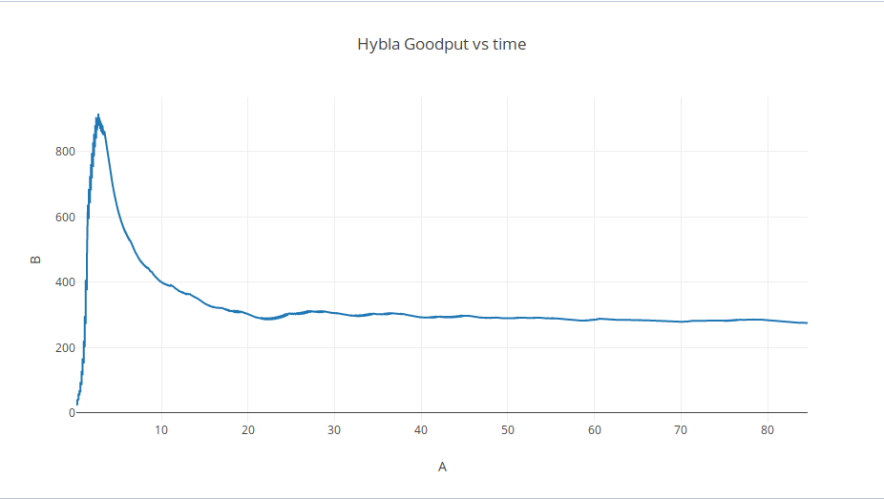

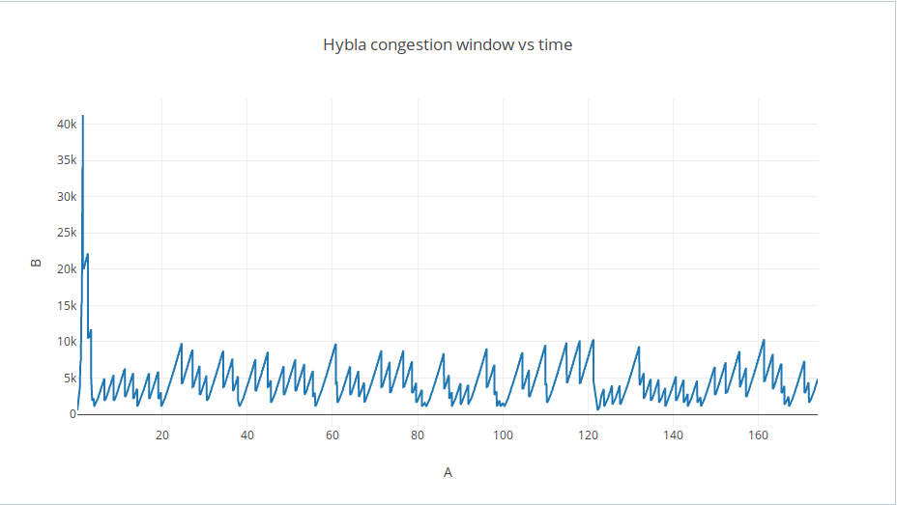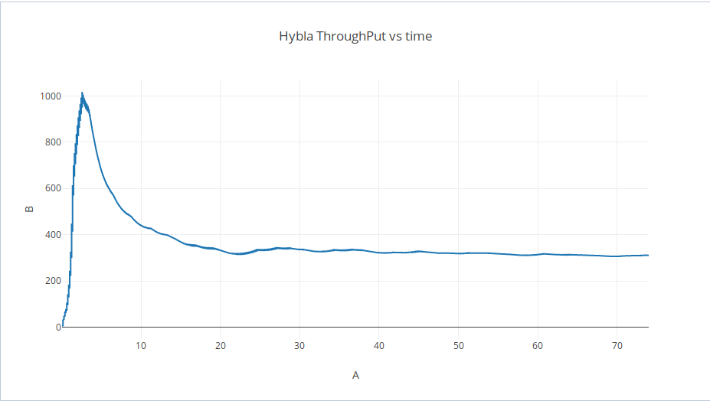

**Congestion Loss for Westwood+:**

Tcp Westwood+ Flow 5 (100.101.3.1 -> 100.101.7.1)

Total Packet Lost: 459

Packet Lost due to buffer overflow: 0

Packet Lost due to Congestion: 459

Maximum throughput(in kbps): 2511.5

Total Packets transmitted:100000000

Packets Successfully Transferred:99999541

Percentage of packet loss (total):0.000459

Percentage of packet loss (due to buffer overflow):0

Percentage of packet loss (duee to congestion):0.000459

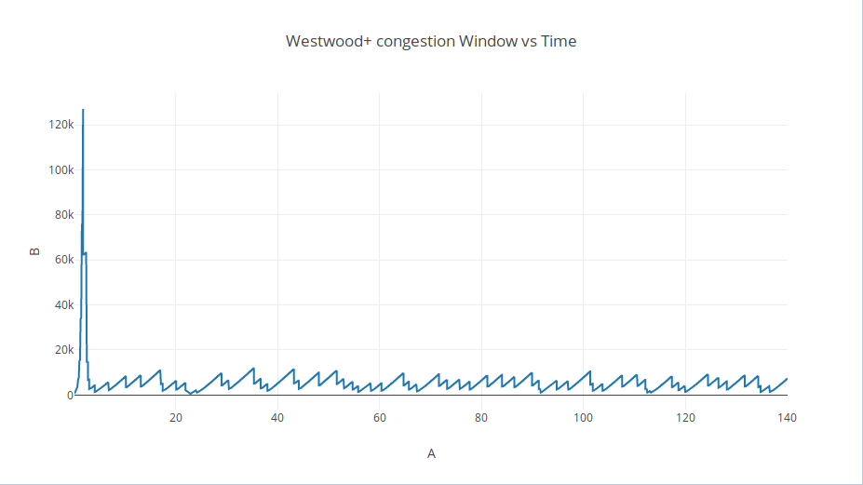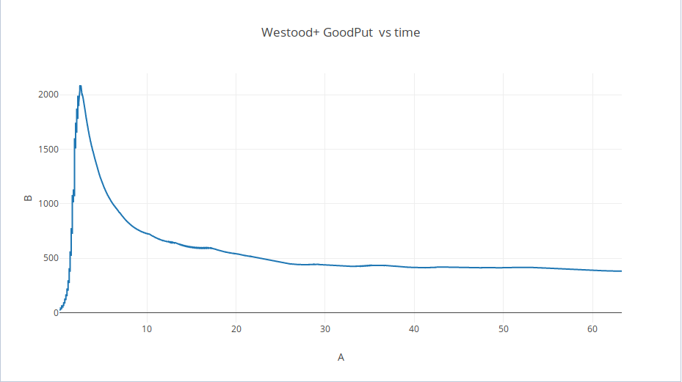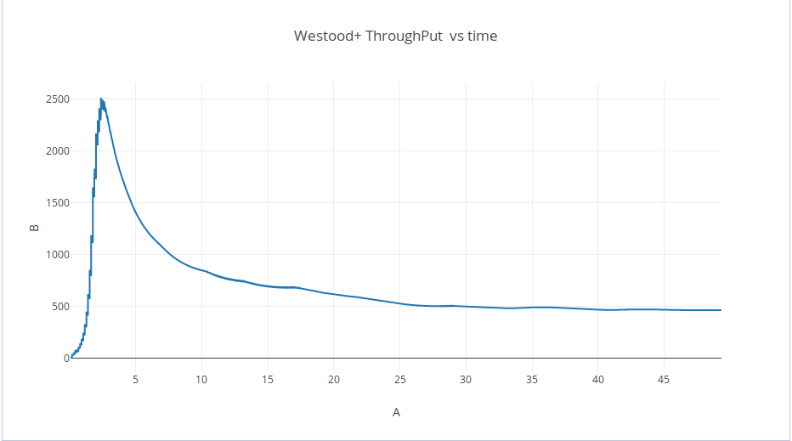

**Congestion Loss in Yeah:**

Tcp Yeah Flow 1 (100.101.1.1 -> 100.101.5.1)

Total Packet Lost: 457

Packet Lost due to buffer overflow: 0

Packet Lost due to Congestion: 457

Maximum throughput(in kbps): 554.446

Total Packets transmitted:100000000

Packets Successfully Transferred:99999543

Percentage of packet loss (total):0.000457

Percentage of packet loss (due to buffer overflow):0

Percentage of packet loss (duee to congestion):0.000457

